**AUTOMATIC ROOM LIGHTNING SYSTEM**

**COMPONENTS:**

1. Ardiuno UNO R3.

2. Electric bulb.

3. Power supply.

4. Light Intensity Sensor.

5. Relay.

6. PIR Motion Sensor.

7. Bread Board.

**CIRCUIT DESIGN:**

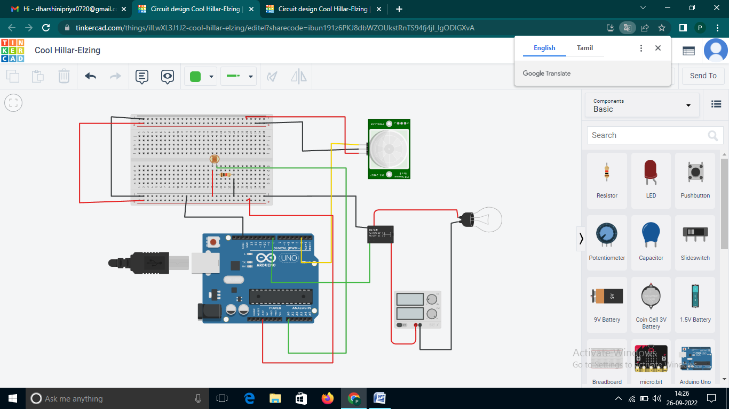

Abstract: Automatic Room Lighting System is a microcontroller based project that automatically turn on or off the lights in a room. The aim of this project is to automatically turn on or off the lights in a room by detecting the human movement. We implemented this project using Arduino UNO Microcontroller and PIR motion sensors.

**PROGRAM:**

// C++ code

//

void setup()

{

pinMode(LED_BUILTIN, OUTPUT);

}

void loop()

{

digitalWrite(LED_BUILTIN, HIGH);

delay(1000); // Wait for 1000 millisecond(s)

digitalWrite(LED_BUILTIN, LOW);

delay(1000); // Wait for 1000 millisecond(s)

}